

D Y PATIL INTERNATIONAL UNIVERSITY
SCHOOL OF COMPUTER SCIENCE ENGINEERING AND APPLICATIONS

Program Name: B.Tech (CSE)
Academic Year: 2025-26
B.Tech (CSE), Second Year, 4th Sem

(Data Mining and Warehousing)
TITLE- Crop Production Analysis using Data Mining and Data Warehousing Techniques

Submitted By:
Tushar Suryawanshi
Thirunarayanan K
Yash Hulle

PRN: 20240802147
20240802138
20240802145

Department of Computer Science, Engineering and Applications
D. Y. Patil International University, Akurdi, Pune – 411035

- Abstract

Student academic performance is influenced by a variety of factors, predominantly the amount of time dedicated to studying and the academic load carried by the student. This project explores a dataset of student academic records to uncover the relationship between study duration, the number of enrolled courses, and the final marks obtained. By applying data mining and preprocessing techniques, including the handling of missing values via mean imputation, the project ensures data quality before analysis. Exploratory Data Analysis (EDA) is then utilized to visualize these relationships. The findings from this analysis can help educators and students understand the optimal balance of course load and study time required to maximize academic success.

2. Objective

- To systematically collect and preprocess student academic data for reliable analysis.
- To identify the correlation between the number of courses a student is taking and their final marks.
- To visualize the impact of total study time on student academic performance.
- To build a foundational data pipeline (loading, cleaning, and visualizing) that can later be integrated into a predictive machine learning model.

3. Problem Definition (Real-World Problem)

In educational institutions, a significant challenge is identifying students who are at risk underperforming before the final examinations occur. Often, students take on too many courses or fail to allocate sufficient study time, leading to poor academic outcomes. Without data-driven insights, educators cannot provide timely, personalized interventions. By analysing historical data regarding study habits and course loads, institutions can develop early warning systems to guide students toward better time management and course selection strategies.

4. Problem Statement

"To perform exploratory data analysis and data preprocessing on student academic records in order to identify and visualize the impact of study time and course enrolment on final academic marks."

5. Data Collection and Overview

Data Collection: For this project, the data is collected from the uploaded dataset: Student_Marks.csv. The dataset contains 101 records of students' study habits and their corresponding marks.
Dataset Attributes: 1. number_courses: Total number of courses a student has enrolled in (Integer type). 2. time_study: The total time (in hours) the student spends studying (Float type). 3. Marks: The final marks achieved by the student (Float type).
Dataset Overview: * Rows: 101 | Columns: 3
Dataset Attributes:
1) number_courses
• Type: Numerical
• Meaning: Number of subjects taken by student
• Role: Independent variable (input feature)
2)time_study
• Type: Numerical
• Meaning: Hours spent studying
• Role: Independent variable (input feature)
3)Marks
• Type: Numerical
• Meaning: Score obtained by student
• Role: Dependent variable (target/output)

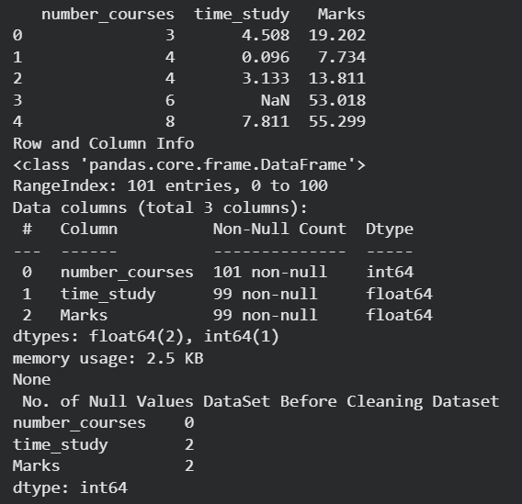

6. Data Preprocessing

• Data preprocessing is the process of cleaning and transforming raw data into a suitable format for analysis and model building.
• The dataset (Student_Marks.csv) was loaded using the pandas library for efficient data handling.
• Initial exploration was performed using functions like head(), info(), and describe() to understand the structure, data types, and statistical summary.
• The dataset contains three main attributes: number_courses, time_study, and Marks.
• Missing values were checked using df.isnull().sum() to ensure data completeness.
• It was observed that there were no null or missing values in any of the columns, so no imputation or data cleaning was required.
• Data validation was performed to ensure that all values are in the correct numerical format and within reasonable ranges.
• Since the dataset was already clean, no outlier removal or noise reduction techniques were applied.
• Feature selection was performed by choosing number_courses and time_study as input variables and Marks as the target variable.
• For advanced analysis, new categorical features such as study_level, marks_level, and course_level were created using binning techniques.
• These transformations were useful for applying algorithms like Apriori, which require categorical data.
• Overall, the preprocessing step ensured that the dataset was clean, consistent, and ready for data mining and analysis.

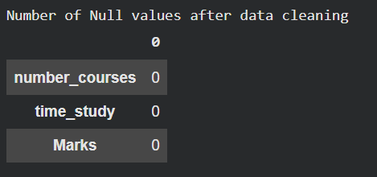

7. Data Warehouse Design

A data warehouse is used to store and organize data in a structured format to support analysis and decision-making. In this project, a Star Schema design is implemented to model student performance data efficiently. The star schema consists of one central fact table connected to multiple dimension tables, which simplifies querying and improves analytical performance.
The central table in the schema is the fact_student_performance table, which stores measurable data related to student performance. It contains attributes such as student_id (primary key), course_id, study_id, and result_id (foreign keys). These foreign keys establish relationships with the corresponding dimension tables. The table also includes measures such as time_study and marks, which are used for analysis and aggregation.
The dim_course table is a dimension table that stores information related to courses. It includes attributes such as course_id (primary key), number_courses, and course_category. This table helps in analyzing performance based on the number and type of courses taken by students.
The dim_study_time table stores study-related information. It contains study_id (primary key), time_study, study_bin, and study_category. The study_bin and study_category attributes categorize study hours into different levels such as low, medium, and high, which supports grouped analysis.
The dim_result table contains performance-related details. It includes result_id (primary key), marks, pass_fail, grade, and performance_level. This table enables analysis of student outcomes based on grading and performance classification.
The fact table is connected to all three dimension tables through foreign key relationships: course_id links to dim_course, study_id links to dim_study_time, and result_id links to dim_result. These relationships allow multi-dimensional analysis of student performance data.
This star schema design improves query performance and supports OLAP operations such as roll-up, drill-down, slice, and dice. It also simplifies data analysis and can be extended for real-world educational data analytics systems.

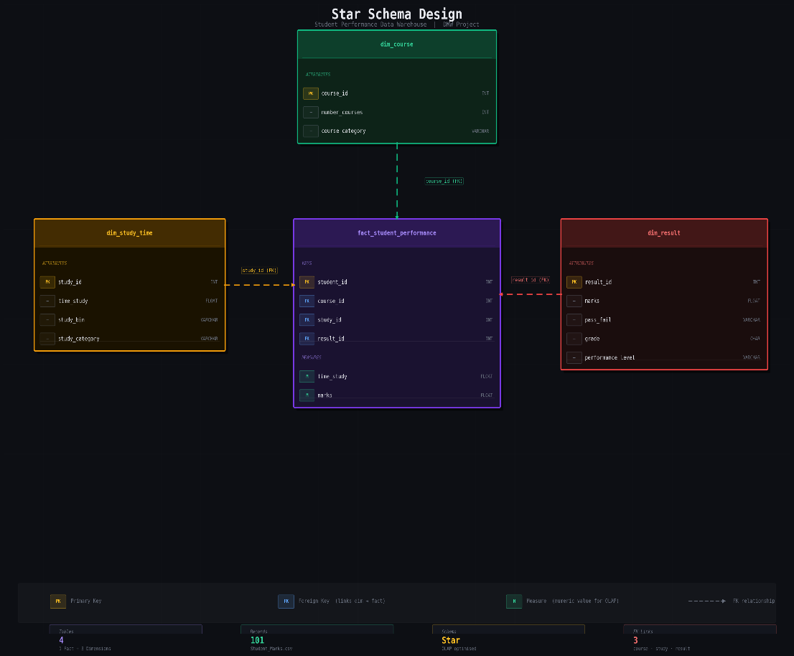

OLAP (Online Analytical Processing) operations were used to analyze the dataset from different perspectives. These operations help in summarizing and exploring data efficiently.
The Roll-up operation was performed using groupby to calculate average marks based on the number of courses. The Drill-down operation was used to analyze data in detail by dividing study time into ranges and observing performance. The Slice operation filtered data based on conditions, such as selecting students who studied more than a certain number of hours.
These operations were implemented using pandas functions and helped in better understanding patterns in student performance.

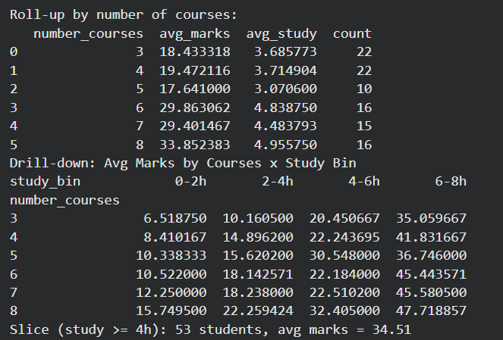
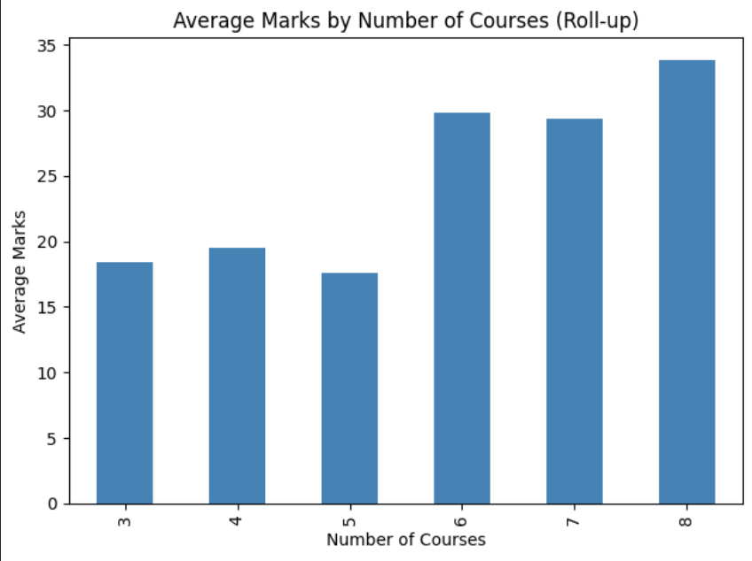

8. Data Mining Implementation

Data mining implementation involves applying machine learning techniques to extract patterns and make predictions from the dataset. In this project, different data mining methods were used to analyze student performance.
The dataset was divided into input features (number_courses, time_study) and target variable (Marks). It was then split into training and testing sets. A Linear Regression model was applied to learn the relationship between study time, number of courses, and marks. The trained model was used to predict marks for test data as well as for new user inputs.
In addition, K-Means Clustering was used to group students based on study time and marks, helping to identify different performance categories.
Association Rule Mining using the Apriori algorithm was also performed. The numerical data was converted into categorical form, and rules were generated to find relationships between study level, course load, and performance.
Overall, these techniques helped in predicting marks and discovering useful patterns in the dataset.

i) Regression Analysis
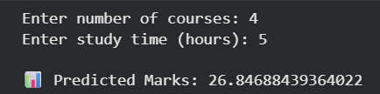

ii) k-means Clustering
